**Product news for internal use**

System pro E power

Anti-seismic withstand

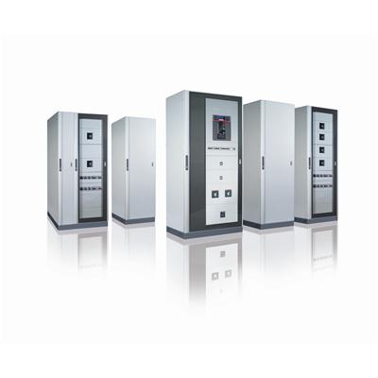

Summary

Introduction 1

Product 1

Reference rules 1

Seismic qualification 1

Anti-seismic tests 4

Suggestions 9

Results 9

|  |  |  |  |  |
| --- | --- | --- | --- | --- |
| Issued by: | GPM |  | **LBU**: | EPPC |
| **Date**: | 3.8.2017 |  | **Distribution**: | External |

# 

# Introduction

Anti-seismic is an important thematic which is proper implemented in ABB by testing product solutions that meet the growing security demands and requirements from different markets.

# Product

This technical information is valid for:

* Main distribution boards: System Pro E Power;
* Main automation boards: IS2 & ISX.

For System pro E power, IS2 and ISX products, ABB guarantees a seismic resistance in standard version without additional reinforcement elements up to 0.5g and with reinforcement kit up to 0.75g

# Reference rules

The reference rules adopted are:

* IEC 60068-3-3 Environmental testing - Part 3: Guidance. Seismic test methods for equipment;
* IEC 60068-2-6 Environmental testing - Part 2-6: Tests - Test Fc: Vibration (sinusoidal);
* IEC 60068-2-57 Environmental testing - Part 2-57: Tests - Test Ff: Vibration - Time-history method;
* IEC 60068-2-59 Environmental testing - Part 2: Tests. Test Fe: Vibration - Sine-beat method;
* IEC 60068-2-47 Environmental testing - Part 2-47: Test - Mounting of specimens for vibration, impact  and similar dynamic tests;
* IEEE Std 693-2005 IEEE Recommended Practice for Seismic Design of Substations;
* Required response spectra applicable to “YATAY” and “DIKEY” sites (Turkey).

In order to meet the anti-seismic requirements, ABB EPPC – PG 3100 offers a seismic qualification, in accordance with CEI EN 62271-207, which determine the total withstand capability of the switchgear assemblies in case of seismic stresses, combining results obtained by test, algebraically results and other service loads.

# Seismic qualification

To determine the seismic qualification, 10 different configurations were seismic tested, using two different laboratories, CESI (Centro Elettronico Sperimentale Italiano), an Italian company founded in 1956, which deals with tests and certifications of electromechanical and electrical systems and Virlab, an Engineering laboratory that provides seismic test in Asteasu, Spain. The data on which the certification is based are the following ones:

* Certified solutions. In particular the certified configurations are System Pro E Power Top Busbar System – 3200 A up to 0.5 g, System Pro E Power Top Busbar System – 3200 A with anti-seismic kit up to 0.75 g, System Pro E Power Rear Busbar System – 4000 A up to 0.5 g, System Pro E Power Rear Busbar System – 4000 A with anti-seismic kit up to 0.75 g.

The anti-seismic kit order codes are represented in the table below:

|  |  |  |
| --- | --- | --- |
| **Description** | **Material Code** | **ABB Code** |
| ANTISEISMIC PLINTH H100 JOINING STRUCT | PPUN0100 | 1STQ002089B0000 |
| N.12 ANTISEISMIC REINFORCEMENT KITS | PRAS0012 | 1STQ002088B0000 |

The front side of TBBS enclosure is represented in the picture below:

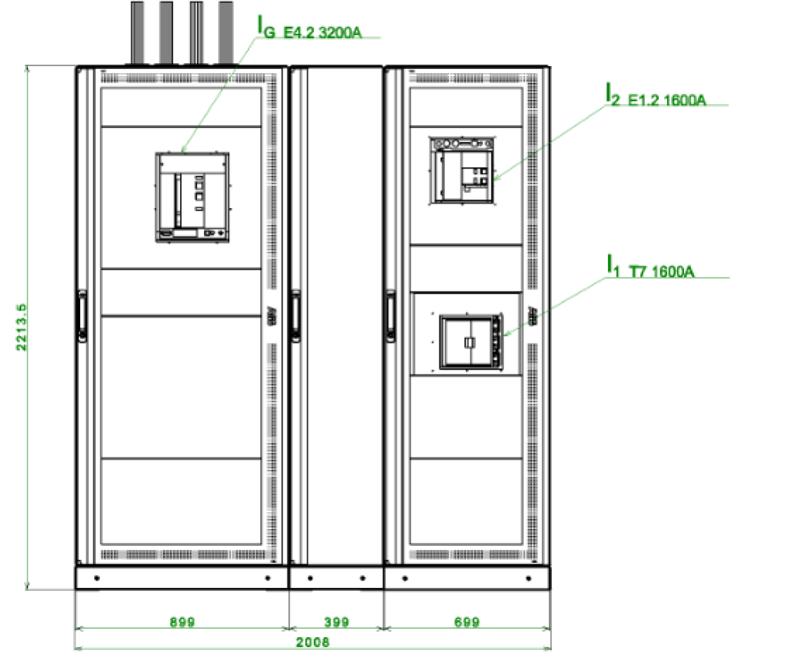

This is representative for all possible configurations: the test have been performed with an internal overall load of almost 2110 kg. The adopted configurations are the ones that our R&D technicians identify as the most critical, due to the presence of plastic tie-rods and, due to the reduced withstand current (Icw), the distance between the busbar holders is increased, which contribute to decrease the resistance in case of seismic events.

The tested RBBS configuration is represented in the picture below:

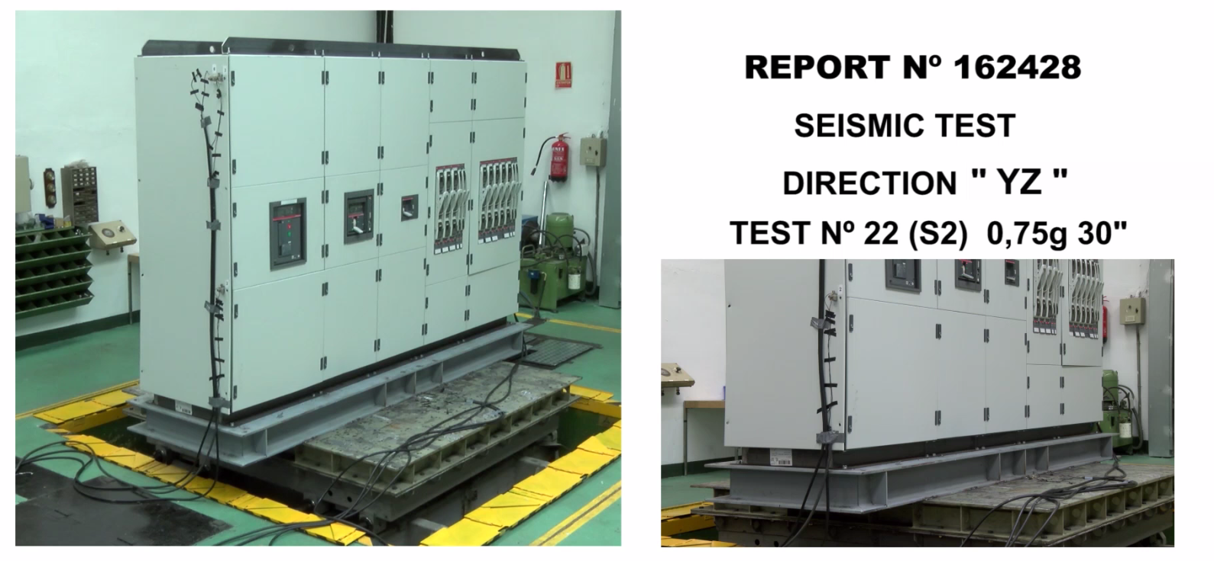

* Historical data on passed ArTu K and IS2 tests.
* FEM Analysis, made during design phase, by creating the structure solid, assuming loads that follow the utilization and fixing proper constraints, it was simulated the deformation on the structure. Also few comparative analysis were performed, such as System Pro E Power vs. ArTu K, System Pro E Power vs. Triline and System Pro E Power vs. major competitors. The purpose of the work is to perform a stress analysis in different electrical panels. The effort and displacement evaluation has to be comparable between the different geometries at the same load conditions.
* Vibration tests. These are different from a seismic event because they are predictable events in a given range, instead the anti-seismic events are unavoidable, non-constant and do not have a precise range. Vibrations can last for hours or be a constant condition; seismic event is a short, impulsive event.
* Customer test data, followed by ABB as external consultants.
* Traction, compression and torsion tests.
* Lifting tests, with ACAE-LOVAG presidia. All lifting tests are performed without paneling (minus 30 % of rigidity without the addition of the external panels and door), with an additional load of 25% (guaranteeing the structure with an additional margin).
* In addition to seismic and vibration tests, System Pro E Powe, in glass door version, has passed the internal-arc test at 65 kA @ 480 V (0.3 s) in conformity with TR61641 (criteria 1-6). In addition, the frame has the capability to resist to a short circuit up to 150 kA for 1 s in conformity to the rule CEI EN 61439-2, in both the TBS and RBBS versions. These induced accelerations are much higher of those of a seismic event (current up to 330000 A that pass through the structure) that cause mechanical stresses higher than seismic events.

# Anti-seismic tests

It has been used the reference of IEE 693-1997 rule, by utilizing the response spectra with a 2% damping, the most critical curve. The accelerometers were positioned in the most critical points, at the top of the structure, close to the switches and close to the bars.

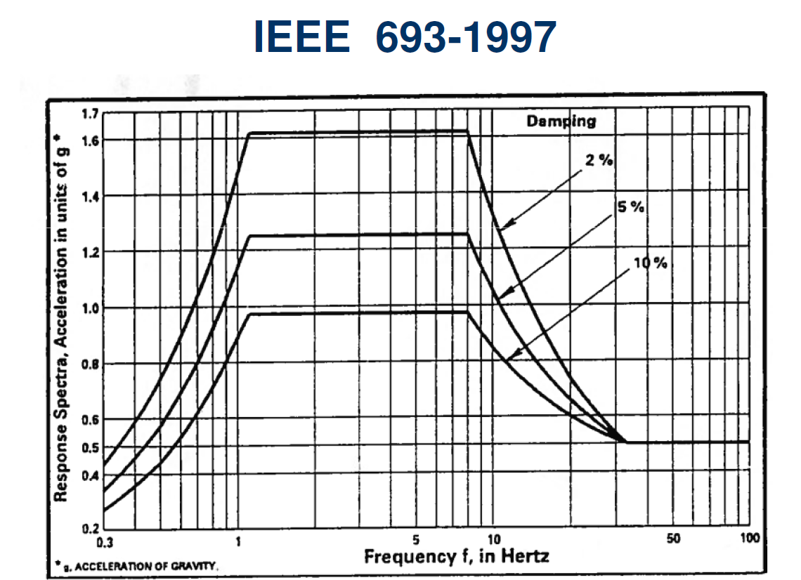

It has been guaranteed in a standard configuration the resistance to a shock level up to 0.5 g, as represented in the picture below:

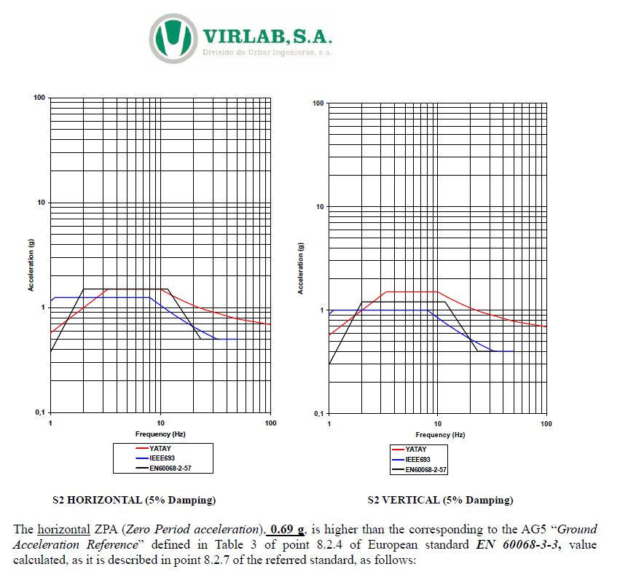

In addition, by installing anti-seismic kit, it has been guaranteed the resistance to a shock level up to 0.75 g, as represented in the picture below:

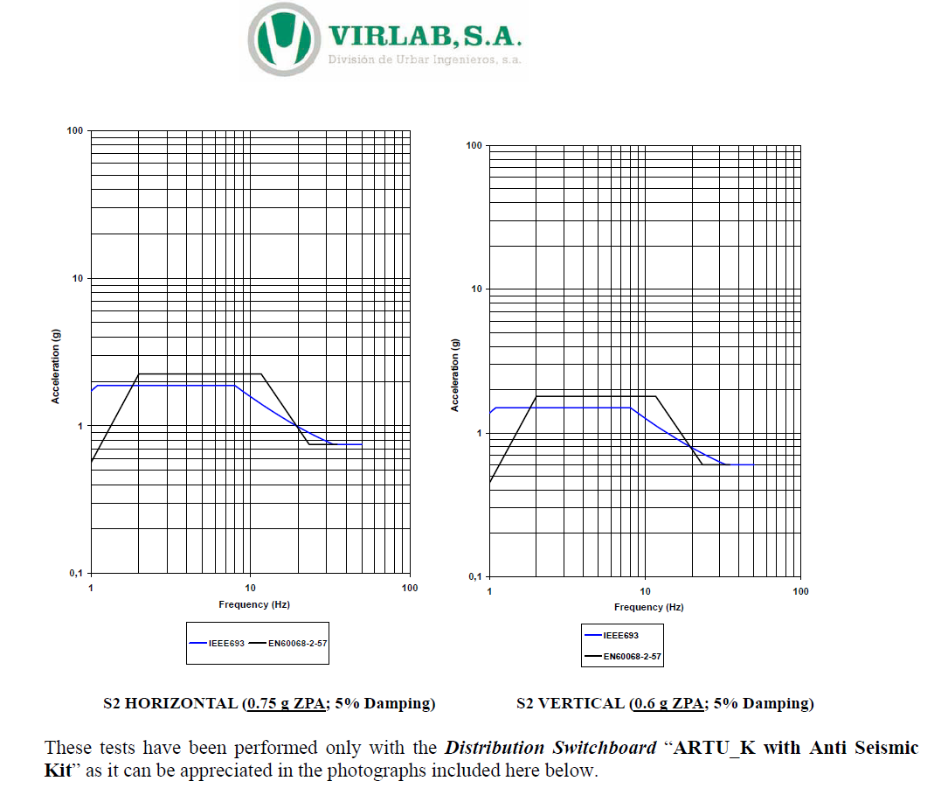

After the seismic event in the defined limits and conditions, it is guaranteed:

* No collapse of the structure.
* Operation of the switchboard after the earthquake.
* Maintaining of the mechanical characteristics, IP and IK.

The results are confirmed by looking to the resonance final and initial benchmarking, which assess that no structural failures occur during tests.

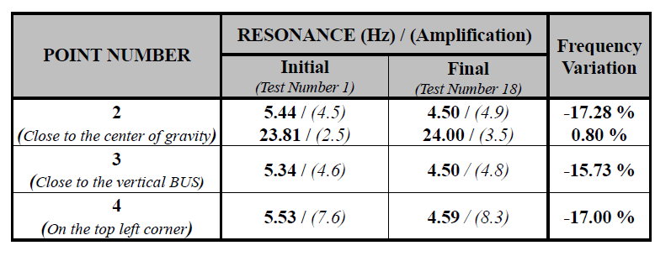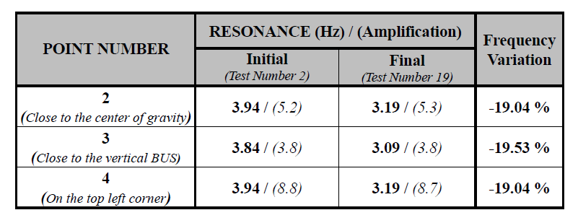

In order to obtain these results, ABB has performed tests with more difficult conditions. In the picture below, it is clearly visible that the test response spectrum is higher than the 0.5g thresholds.

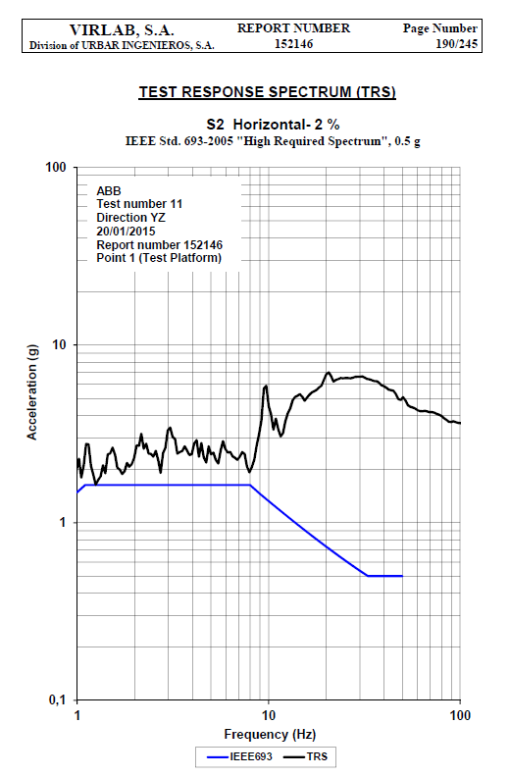

The anti-seismic tests on the structure are combined with the ones performed on the breakers. As visible on the below picture, the accelerations tested on breakers are higher than the ones tested on the SPEP. This is because, in case of an earthquake, the breaker is subject of the vibration of the building and simultaneously of the enclosure.

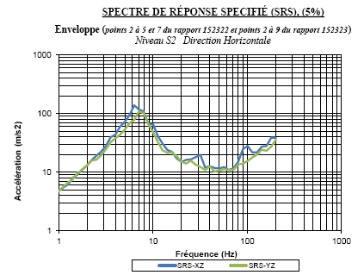

By having significantly higher ZPA tested, it is possible to guarantee the operation of the switchboard during and after a seismic event.

# Suggestions

Some suggestions are provided in order to increase the capability of the switchboard to withstand to a seismic event:

* It is better to distribute the weight at the bottom of the switchboard.
* Tighten the structure, by segregating it or by increasing the number of busbar holders.
* Fixing of floor structure with M12 class 8.8 screws.
* Avoid fixing the frame to the wall, possibly keeping a distance of 600mm to avoid the "hammer" effect during the earthquake, if there is no space make sure the wall is structured for fastening.
* Give maintenance instructions, for example after a seismic event of 0.5g check the tightening torques.
* Busways can compromise stability.
* If it is possible, it is better to reduce height dimension of the enclosure.
* Two structures side by side carry more than a single one.
* The lifting bar strengths the structure.
* If you have a cable feed, expect an additional length in the cables.

# Results

The seismic zones around the World are represented in the picture below:



Below, the comparison table between the IEC 68-3-3 seismic zones, the Richter scale, the Mercalli scale, and the acceleration value.

